Freshco Hypermarket Capstone

Introduction

* Freshco Hypermarket, situated in HSR, Bangalore, has established itself as a prominent supermarket in the region, catering to a wide range of customers. In response to evolving customer needs and to enhance convenience, Freshco introduced a home delivery service in the year 2021.
* This report represents a comprehensive analysis of the Freshco’s transition data sheet giving detailed information at the order level. The following analysis is divided into four parts, each part giving insights of a particular trend.

**Order Level Analysis**

* Identifying order pattern across delivery area and time slot. Highlighting areas having higher order count.
* Identifying areas having highest increase in monthly orders (from Jan to Sep).
* Calculated delivery charges and discount as a percentage of product amount at slot and month level.
* Calculated discount as a percentage of product amount at drop area and slot level.  
    
  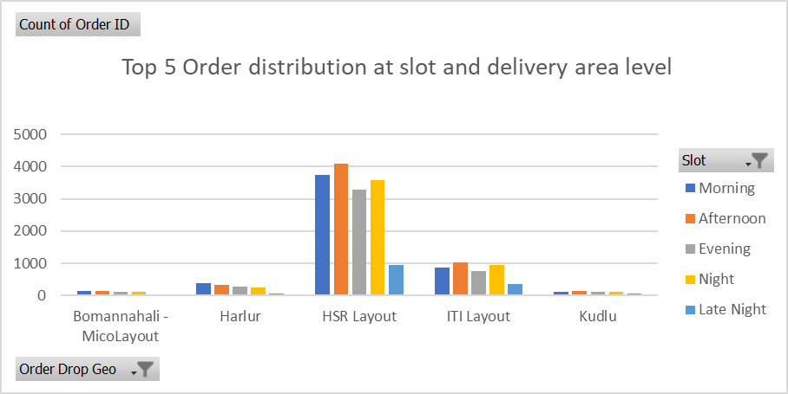

**Completion Rate Analysis**

* Analyse pattern in order completion rate across delivery time slot and day of the week this analysis will help in allocating resource and time frame.
* Calculate completion rate at drop area level which makes us understand the distance of the drop location from the pickup location and will make us optimize the delivery performance and cost.
* Reviewing completion rate at number of products ordered level and bringing out insights on customer behaviour.
* Analysing the order completion pattern, we can conclude the performance index of the store and work on improving the delivery matrix.

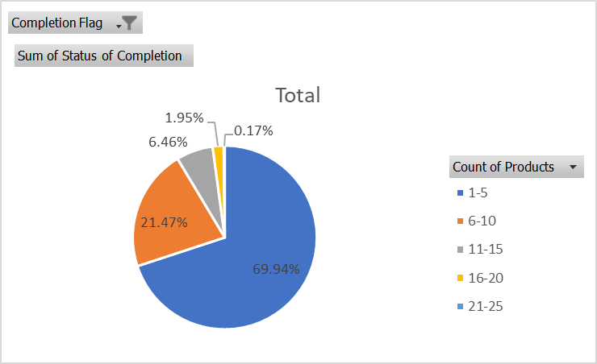

Less count of product has more completion rate due to less quantity and fast delivery

**Customer Level Analysis**

* Identifying potential customer from various source which can help in understanding marketing dynamics.
* Finding LTV(Lifetime Value) of each customer at source level and month level understanding their ordering pattern
* Calculating average Revenue per order at different customer acquisition source level to enhance profitability.
* Calculating average Revenue per order at acquisition month level for pricing and promotional decision.
* Explored order rating across slots, number of items placed, delivery charges, discount and find similar pattern with enhancement in service improvements.

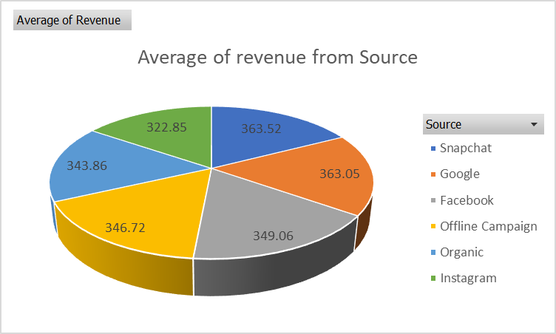

**Delivery Analysis**

* Calculated average overall delivery time at month and delivery area level. This makes the delivery process efficient.  
  Analyse average overall delivery time at month and weekday/weekend level to identify customer engagement
* Calculated average overall delivery time at slot level
* Examining pattern between delivery charges and delivery time with slot or delivery area to understand customer requirement and increase customer satisfaction.

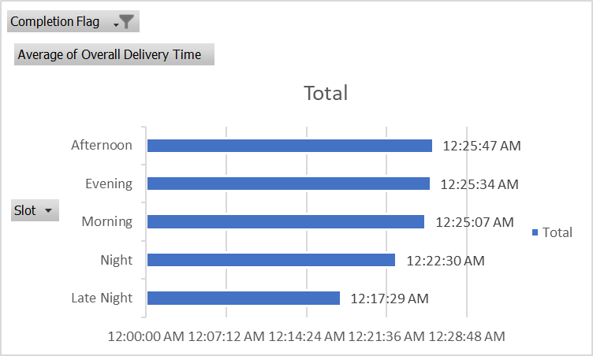

Late night slot has less order and delivery time due to less traffic at night.

Conclusion

This report shows insights of various factors that contribute in the operation of the Freshco Hypermarket. Examining the data sheet we came across four level of analysing the data i.e

Order level, Completion level, Customer level and Delivery level. These level gives overall performance index in various factors and we can plan new strategies to work on making improvements.

Based on the data I have highlighted the most efficient area to find pattern to optimize the rest in the category. This data driven approach look for better opportunity for enhancing marketing strategies, better decision-making approach, improved target plans and robust performance measure.

With systemic monitoring data we can keep up to the latest trends and proactive approach of making service efficient and maintaining higher level of customer satisfaction.

Prepared By -

Kumari Shreya